**Pinwheel Tutorial**

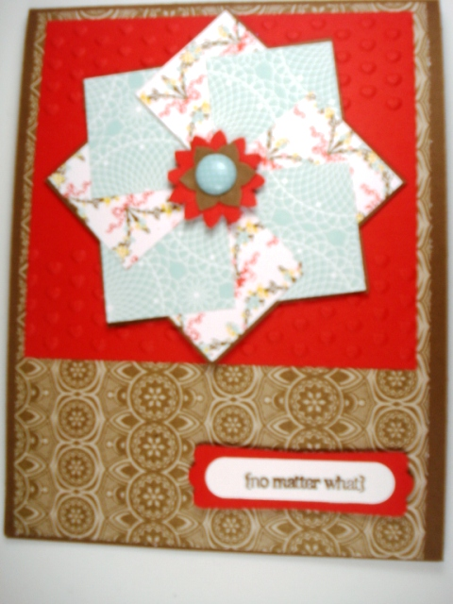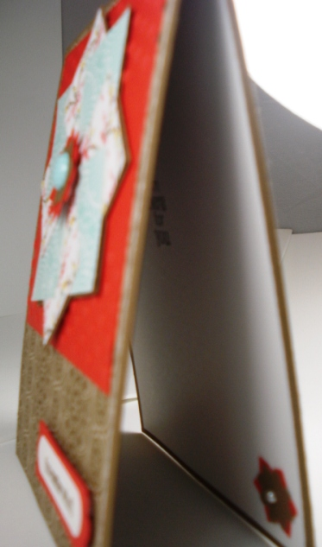

Pinwheel Tutorial (better late than never right?)

It's called a Pinwheel card and it's a great way to use up little pieces of scrap paper that you have collecting. It looks complicated and time-consuming, but it's really very simple! Just follow the step-by-step tutorial below.

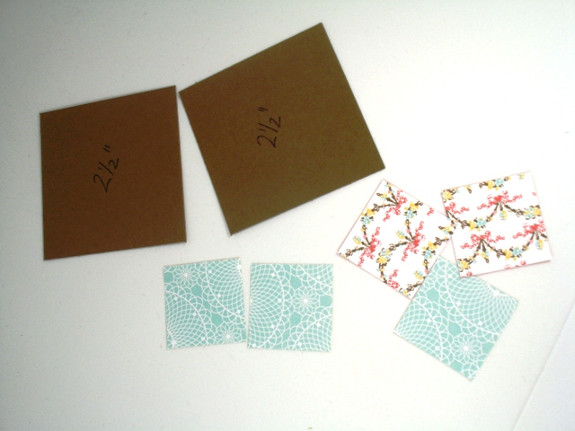

**Step One:**Begin by punching 8 squares of Designer Series Paper with the 1 1/4" Square Punch. Punch two coordinating patterns (4 of each), and cut two pieces of Cardstock 2 1/2" square.

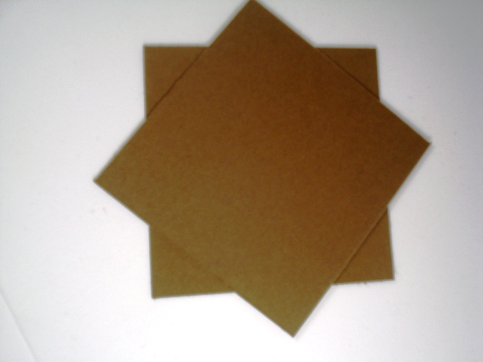

**Step Two: Adhere one of the 2 ½” pieces on top if the other, like the pic above. It should look like a 8-point star.**

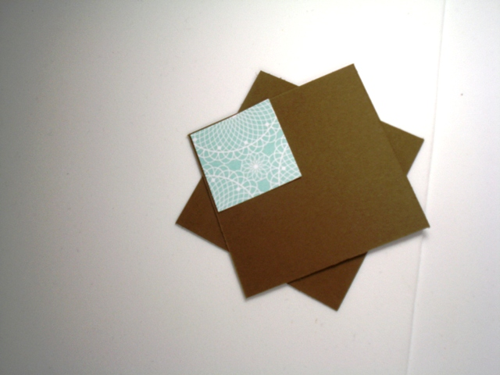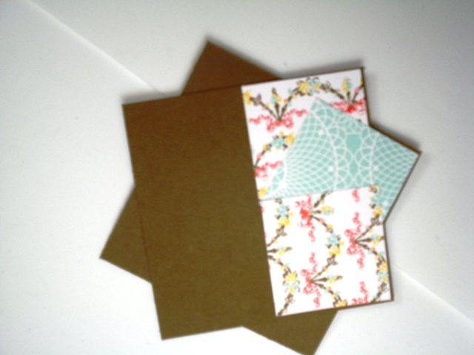

**StepThree:** Begin attaching the assembled squares to your larger squares (star). Attach the corner only of the first small square, and adhere the rest completely.

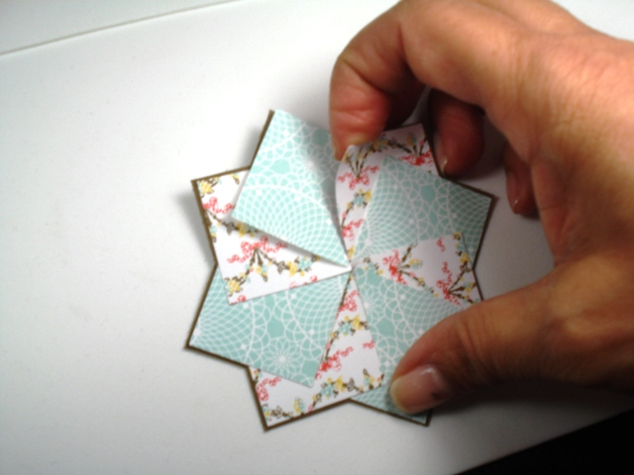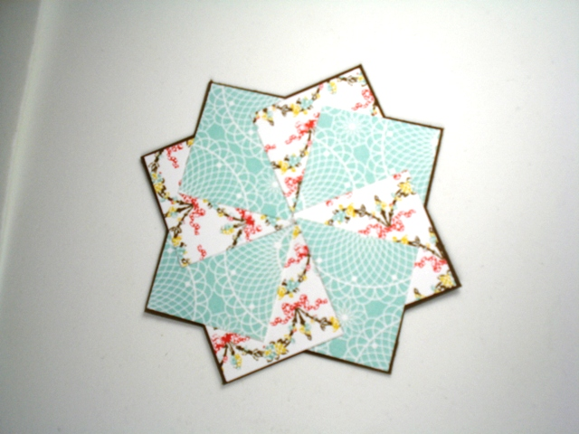

**Step Four:** The reason you only the right corner of the very first square you place on the star is because you will need to life it (the first square) and “tuck” the last square underneath it for a perfect star!

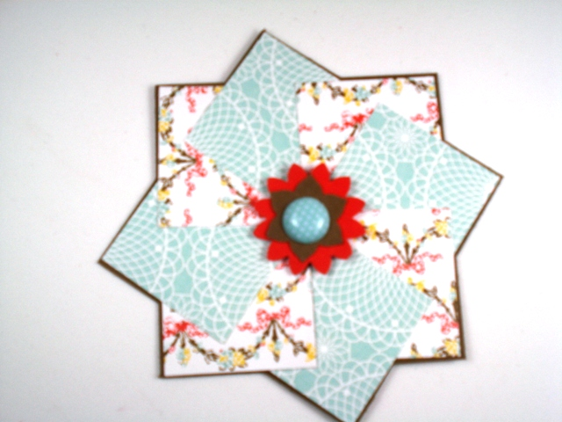

 S**tep Five:**  Finish off the center with a small punched shape and a Brad, button or other embellishment. You are done with the pinwheel piece. Now attach it as an element to you full card.



And that's how you create a Pinwheel card! I told you it was fast and easy! I simply attached mine to a 4 x 5.25" piece of Designer Series Paper and mounted that on a layer of Cardstock and then the Card Base. The sentiment is from the Stamp Set "Petite Pairs".

